SUPPLEMENTARY DATA
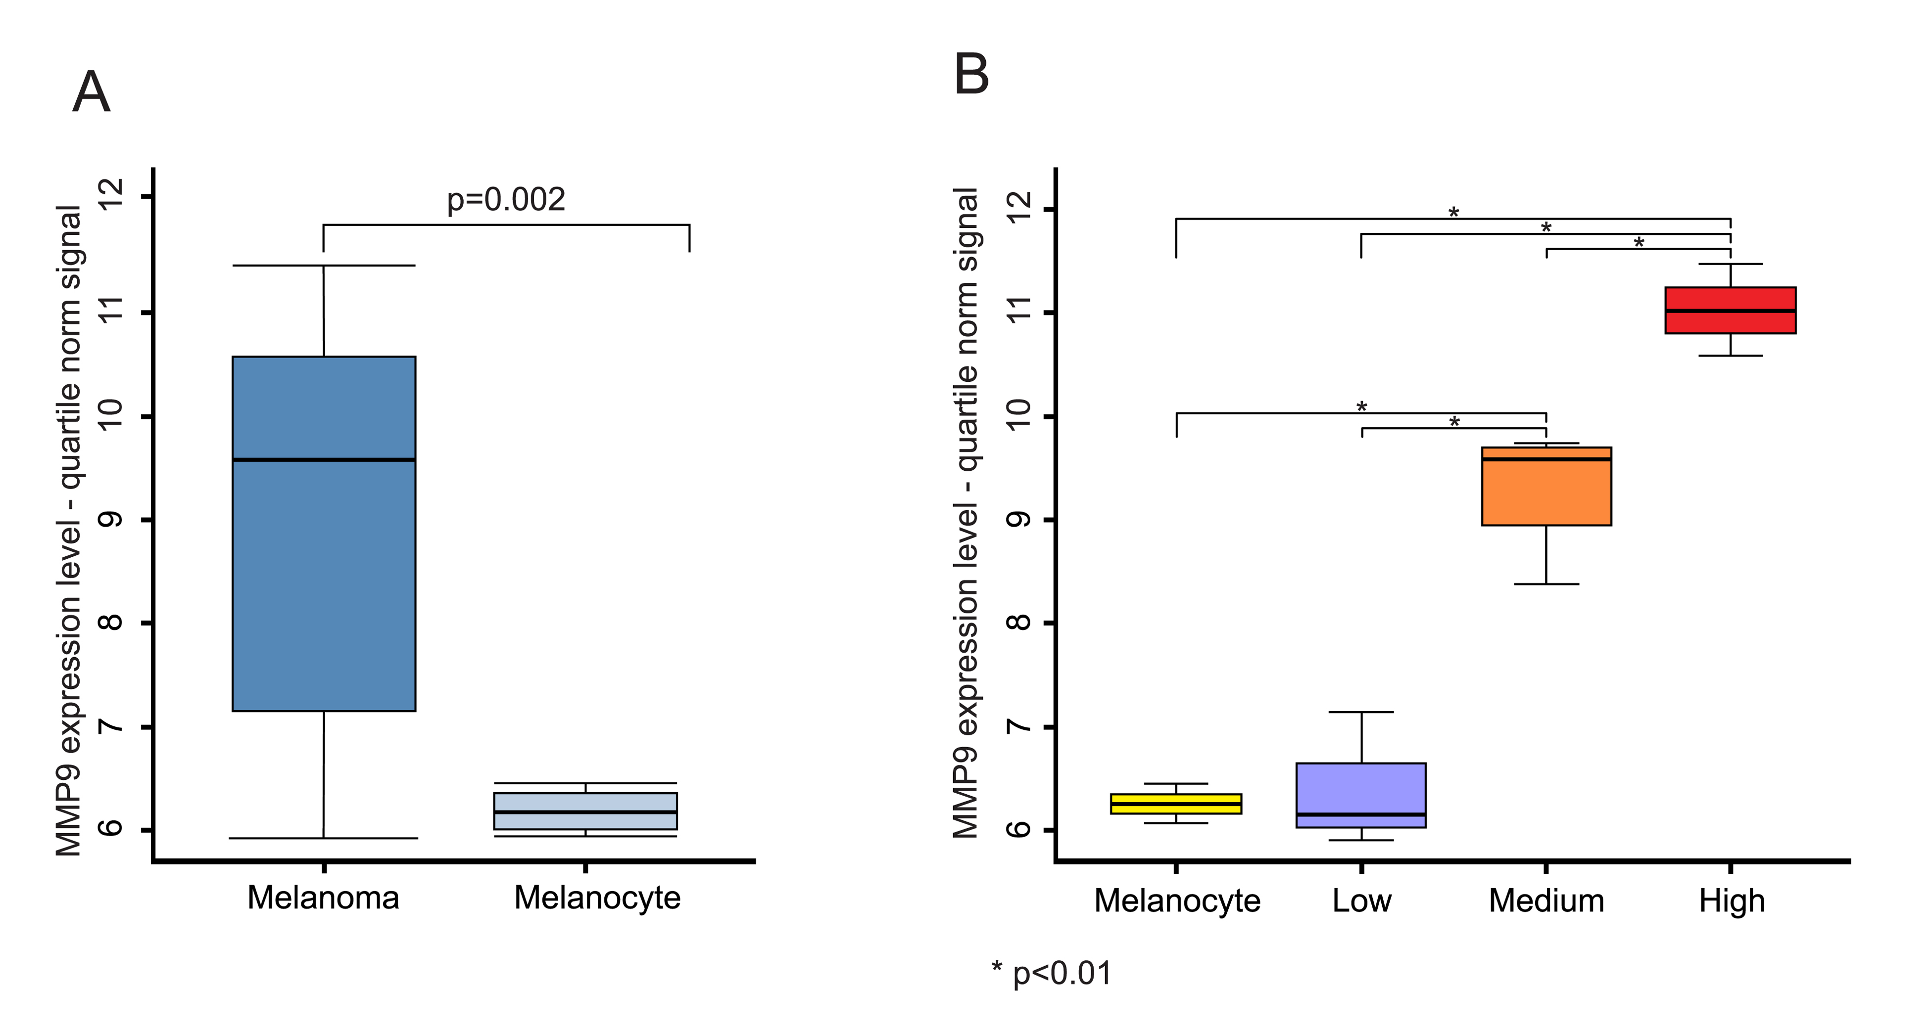

Figure S1. Microarray analysis of MMP-9 expression levels in melanoma samples. (A) Differential analysis of MMP-9 expression between melanoma samples and melanocyte controls. (B) Statistical analysis among melanoma samples stratified in low, medium and high expression group according the MMP-9 expression levels.

Table S1. CpG islands of MMP-9 gene according to CpG Islands Tracks available in UCSC Genome browser.

Region name | *Chromosome position | Size | CpG count
CpG 1 | chr20:46010497-46011349 | 853 | 65
CpG 2 | chr20:46011650-46012571 | 922 | 63
CpG 3 | chr20:46013456-46013767 | 312 | 24
CpG 4 | chr20:46013967-46014472 | 506 | 57
*Human Dec. 2013 (GRCh38/hg38) Assembly

www.impactaging.com 1 AGING, May 2016, Vol. 8 No.5

Table S2. Pearson Correlation analysis between methylation probset levels and the levels of MMP-9 expression. For each probset, chromosome position, nucleotide sequence and region in which it belongs were reported.

Region | *Chromosome position | Sequence | R | p
Promoter | chr20:46006492-46006543 | TCATATTACTCTATGACCTCACATTCCCGAGTCTAGAATCTAGTTCCTCCTG | -0.14 | 0.5549
Promoter | chr20:46006592-46006641 | TTACCTTCAGTGGGTAGCAGGGGACCAGAGGAGAAGCATCCAGGTTTTAT | 0.18 | 0.8355
Promoter | chr20:46006668-46006724 | TACCCACTTCTATACCTGGGTCATCACAGTTCCCTGTAAATGGTAATAAAGATGAAA | 0.06 | 0.5903
Promoter | chr20:46006768-46006817 | GGATTAACTCGCTCTGTGATCACAGGCAAATTCCTTAACTCTCTGAGCCT | -0.16 | 0.7741
Promoter | chr20:46006870-46006920 | TGGTGAGGATGAAACGAGAGGCTTATAGAGAACTTATTACGGTGCTTGACA | -0.09 | 0.7255
Promoter | chr20:46006992-46007041 | CTGGAAAATGGCAGAGCCGGGATGGAAATCCAGGACTTCGTGACTGCAAA | -0.11 | 0.1782
Promoter | chr20:46007090-46007152 | AGGAAGTTAATTATCTCCATCTCACAGTCTCATTTATTAGATAAGCATATAAAATGCCTGGCA | 0.4 | 0.0063
Promoter | chr20:46007492-46007542 | CAACTTTTTGAGTTGTTAGCAGGTTTTTCCCAAATAGGGCTTTGAAGAAGG | 0.71 | 0.1293
Promoter | chr20:46007592-46007641 | GGAGGCTGCTGGTGTGGGAGGCTTGGGAGGGAGGCTTGGCATAAGTGTGA | 0.44 | 0.8936
Promoter | chr20:46007674-46007723 | AGGGCTGGAGAACTGAAAGGGCTCCTATAGATTATTTTCCCCCATATCCT | 0.04 | 0.956
Promoter | chr20:46007788-46007838 | TGCAGCTTAGAGCCCAATAACCTGGTTTGGTGATTCCAAGTTAGAATCATG | 0.02 | 0.956
Promoter | chr20:46007992-46008041 | GCCCTGAATCTTGGGTCTTGGCCTTAGTAATTAAAACCAATCACCACCAT | -0.13 | 0.6784
Promoter | chr20:46008096-46008145 | TTTAATCCTCACATCAATTTAGGGACAAAGAGCCCCCCACCCCCCGTTTT | -0.33 | 0.2704
Promoter | chr20:46008202-46008251 | AAGGAAGAGAGTAAAGCCATGTCTGCTGTTTTCTAGAGGCTGCTACTGTC | -0.43 | 0.1433
Promoter | chr20:46008314-46008363 | AGCCTTGCCTAGCAGAGCCCATTCCTTCCGCCCCCAGATGAAGCAGGGAG | -0.13 | 0.6831
Promoter | chr20:46008398-46008447 | AAAAAGAGGACAGAGCCTGGAGTGTGGGGAGGGGTTTGGGGAGGATATCT | -0.41 | 0.1593
Promoter | chr20:46008502-46008551 | TTCAGAAAGAAGTCTCAGGGAGTCTTCCATCACTTTCCCTTGGCTGACCA | -0.16 | 0.6093
Promoter | chr20:46008602-46008651 | TCCCTCCCTTTCATACAGTTCCCACAAGCTCTGCAGTTTGCAAAACCCTA | -0.33 | 0.2647
Promoter | chr20:46008692-46008741 | TCTTGCCTGACTTGGCAGTGGAGACTGCGGGCAGTGGAGAGAGGAGGAGG | -0.38 | 0.1972
Promoter | chr20:46008810-46008859 | ACACACACACCCTGACCCCTGAGTCAGCACTTGCCTGTCAAGGAGGGGTG | 0.64 | 0.0187
Promoter | chr20:46008892-46008941 | AACAGCAGCTGCAGTCAGACACCTCTGCCCTCACCATGAGCCTCTGGCAG | -0.38 | 0.1987
Intron 1 | chr20:46009008-46009057 | CTTGTGCTCTTCCCTGGAGACCTGAGAACCAATCTCACCGACAGGCAGCT | -0.36 | 0.2273
Intron 2 | chr20:46009108-46009157 | GGGTGTTGAGTGTCCCAGAGAGGATGCAGGGCCTCAGAGGAGATGCTTTA | -0.47 | 0.1054
Intron 3 | chr20:46009208-46009257 | TTAGGCAGTGGGGGGTCTTGTGGAGGCTTTGAGCAGTGATGGCCAGAAAT | -0.48 | 0.1008

www.impactaging.com 2 AGING, May 2016, Vol. 8 No.5

Intron 4 | chr20:46009317-46009366 | GAGGGTTCTGGGGTAAGCATAGGCTGGGAGTGAACAGGGGCAAACCTTAT | -0.5 | 0.0813
Intron 5 | chr20:46009413-46009462 | GAGCTGAGGATGTCTAAGGAGGGGAGATCCCTGGGTGGTCAGAAAGCACT | -0.63 | 0.0216
1CpG | chr20:46010496-46010545 | TCGGAAGACTTGCCGCGGGCGGTGATTGACGACGCCTTTGCCCGCGCCTT | 0.53 | 0.0601
1°CpG | chr20:46010604-46010653 | GACATCGTCATCCAGTTTGGTGTCGCGGGTGAGAACGTGAGGAGGGAAAA | 0.38 | 0.195
1°CpG | chr20:46010720-46010769 | GGCTTCCTCTTGCCTGCCCGCGCTGCCCTGGCTTATACGGCCCCTCCTGC | 0.42 | 0.1579
1°CpG | chr20:46010804-46010853 | AGAGCTTCGCGCAGGCGGGATTTCAGCCCGCACTTATTTCGGAGCCCTTG | 0.51 | 0.078
1°CpG | chr20:46010912-46010961 | GTTTCTTCAGAGCACGGAGACGGGTATCCCTTCGACGGGAAGGACGGGCT | 0.12 | 0.7051
1°CpG | chr20:46011008-46011057 | CATTTCGACGATGACGAGTTGTGGTCCCTGGGCAAGGGCGTCGGTGAGAT | 0.03 | 0.9121
1°CpG | chr20:46011116-46011165 | TAACTCCGGTCCCCCCTCCTCCTGCAGTGGTTCCAACTCGGTTTGGAAAC | 0.04 | 0.8886
1°CpG | chr20:46011216-46011265 | CTCTGCCTGCACCACCGACGGTCGCTCCGACGGCTTGCCCTGGTGCAGTA | 0.47 | 0.1047
1°CpG | chr20:46011296-46011345 | TTGGCTTCTGCCCCAGCGAGAGTGAGTGAGGGGGCTCGCCGAGGGCTGGG | 0.12 | 0.6945
2°CpG | chr20:46011672-46011721 | TCCGACGGCTACCGCTGGTGCGCCACCACCGCCAACTACGACCGGGACAA | 0.6 | 0.0313
2°CpG | chr20:46011750-46011799 | ACCTCCACCCTGTCTACCAGGTTCAGCCCCGCCCTCTCATCATGTATTGG | 0.5 | 0.0789
2°CpG | chr20:46011868-46011917 | TGACTCCGCCCACCTACACCACATTTCCACCACTATCCCTGACTTCCAAT | 0.63 | 0.0215
2°CpG | chr20:46011968-46012017 | TCTTCCTTGGTCTGGTGTCCCAGGCACCGCCCACGGGTCTAGCCTCTTCT | 0.61 | 0.0265
2°CpG | chr20:46012056-46012105 | GTTTAGCTCCCTGTCGGGTCGGCCCCTGACTCCTTATTGGACTCATCCAT | 0.67 | 0.0114
2°CpG | chr20:46012174-46012223 | GCTGTGCGTCTTCCCCTTCACTTTCCTGGGTAAGGAGTACTCGACCTGTA | 0.89 | 0
2°CpG | chr20:46012250-46012299 | CTCTGGTGCGCTACCACCTCGAACTTTGACAGCGACAAGAAGTGGGGCTT | 0.87 | 0.0001
2°CpG | chr20:46012374-46012423 | CAGGGCTGGGGGCTCGGCCCGGCGCTCACGTCTCAGGCTCCCTCTCCCTC | 0.69 | 0.0089
2°CpG | chr20:46012472-46012521 | TGGGCTTAGATCATTCCTCAGTGCCGGAGGCGCTCATGTACCCTATGTAC | 0.67 | 0.0127
2°CpG | chr20:46012550-46012599 | AGGACGACGTGAATGGCATCCGGCACCTCTATGGTGAGGCAGGGGCAGGG | 0.8 | 0.0009
3°CpG | chr20:46013265-46013314 | TGAACCTGAGCCACGGCCTCCAACCACCACCACACCGCAGCCCACGGCTC | -0.05 | 0.8632
3°CpG | chr20:46013379-46013428 | CACAGGTCCCCCCTCAGCTGGCCCCACAGGTCCCCCCACTGCTGGCCCTT | 0 | 0.9947
3°CpG | chr20:46013461-46013510 | GACGATGCCTGCAACGTGAACATCTTCGACGCCATCGCGGAGATTGGGAA | 0.21 | 0.5001
3°CpG | chr20:46013585-46013634 | GCCCGTCCCTTCCCGCCCACTGGCCCTGTGTCCAAGGCTTAGAGCCCGTC | 0.19 | 0.5286
3°CpG | chr20:46013685-46013734 | GGGAGCCGGCCGCAGGGCCCCTTCCTTATCGCCGACAAGTGGCCCGCGCT | -0.24 | 0.4315
3°CpG | chr20:46013763-46013812 | GAGCGGCTCTCCAAGAAGCTTTTCTTCTTCTCTGGTTAGTTACCTACTTT | 0.06 | 0.8503
3°CpG | chr20:46013862-46013911 | ATCGATAACCCACGAAACGTCTTGTGCGTTTTAGAAAAATACGCCCCCTG | 0.02 | 0.9419

www.impactaging.com 3 AGING, May 2016, Vol. 8 No.5

4°CpG | chr20:46013962-46014011 | CTCCACGCCCTCGCGTCGCTCTACCCAGCGCCTCTGCCCCTGGGTTGCAG | 0.32 | 0.2922
4°CpG | chr20:46014066-46014115 | TCTAGGAGTACGTGCTCCCTCTGCGCCCCCAAACCGACGTGACCCTCCTC | 0.08 | 0.8071
4°CpG | chr20:46014164-46014213 | CCCGAGGCGTCTGGACAAGCTGGGCCTGGGAGCCGACGTGGCCCAGGTGA | 0.36 | 0.2217
4°CpG | chr20:46014286-46014335 | CGCGGCCGCCGGCAGGGGGAGCCCGGGCGCCGTCGGTCCGTCCGCTAGCC | -0.17 | 0.5722
4°CpG | chr20:46014372-46014421 | TTCGACGTGAAGGCGCAGATGGTGGATCCCCGGAGCGCCAGCGAGGTGGA | 0.17 | 0.5791
4°CpG | chr20:46014482-46014531 | CTGAGGAGGATCCCTTCGTGAGACACCACACTAAGCTCCTCTTAGTGAGT | 0.05 | 0.8791
4°CpG | chr20:46014586-46014635 | AGCACAGACAAGATCCCAGCAGAGGCAGAGGCCTTCTCCAGGTCATTTAG | -0.06 | 0.836
*Human Dec. 2013 (GRCh38/hg38) Assembly

Table S3. Primers and real time amplification conditions.
RT-qPCR:
 | MMP-9 forward | 5’-GAACCAATCTCACCGACAGG-3’ | 94°C for 10 min, followed by forty cycles of 94°C for 15 s, 64°C for 40 s and 72°C for 1 min.
 | MMP-9 reverse | 5’-CCACAACTCGTCATCGTCG-3’
 | PGK-1 forward | 5’-TTAAAGGGAAGCGGGTCGTT-3’
 | PGK-1 reverse | 5’-CAGGCATGGGCACACCAT-3’
MSRE-qPCR:
 | CpG 2 hotspot forward | 5’- GTGCGCTACCACCTCGAACT-3’ | 94°C for 10 min, followed by forty cycles of 94°C for 15 s, 62°C for 20 s and 72°C for 40 s.
 | CpG 2 hotspot reverse | 5’-AGGCTCTGCTTCCAGACAGACG-3’

www.impactaging.com 4 AGING, May 2016, Vol. 8 No.5

